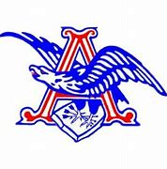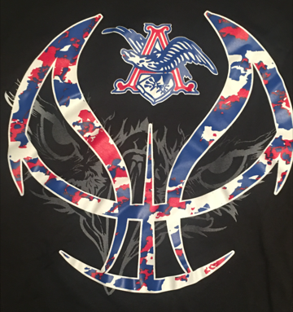
Apollo Boy’s Youth Basketball League
2022-23 Application

Dear Eagle Nation,
It is now time to sign-up for the New and Improved Apollo Youth Basketball League. The attached sign-up form must be completed, signed and returned to Coach Mark Starns at Apollo High School by November 19th, 2022. Fees are $60 for the first child, $50 for the second child and $40 for each subsequent child. Evaluations and Draft will be held at Apollo High School on Saturday December 3rd from 8:00-12:00. Games will be played at Apollo High School on Saturdays or Sundays from December 10th – February 11th. Like last season, the league will be divided by grade (the player’s grade for the 2022-2023 school year) in the following manner.
- Instructional League K, 1st & 2nd Grade
- Junior Varsity League 3rd & 4th Grade
- Varsity League 5th & 6th Grade

Please return the Registration Form and your fee to the address below.
Make check payable to Apollo ABA, and mail to:
Mark Starns
Apollo ABA
2280 Tamarack Road
Owensboro, Kentucky 42301
If you have questions, email:
Jeff Johnson jeffrjohnson4@gmail.com
Be sure to Follow us on Twitter: @AHSEaglesBBall

Apollo Boy’s Youth Basketball League
2022-23 Application

Name (First) _______________________________ (Last) _________________________ Grade ___________
Address __________________________________________________________________________________
School __________________________________ Youth T-Shirt Size ____________ or Adult Size _________
Age as of November 1, 2022___________ Date of Birth __________________
Phone _______________________________ (Please list the best number to contact parent)
Parent Email _____________________________________
Mother's Name ____________________________________ Number (cell or work) _____________________
Father's Name _____________________________________ Number (cell or work) ____________________
ARE YOU WILLING TO HELP COACH IN THE 2022-23 SEASON?
Yes- Head Coach Yes- Assistant Coach
Apollo ABA Eagle Youth League does not provide health insurance; it is the parents/guardians responsibility to carry insurance in case of accident or injury.
I, the undersigned, verify that my child is physically fit to participate in the Apollo ABA Youth Basketball League. We agree not to hold Apollo High School, or anyone associated with Apollo ABA or Daviess County Public Schools responsible in case of accident, injury or any COVID related illnesses.
Insurance Company _______________________________ Policy # __________________________________
Signature of parent/guardian _____________________________________ Date ________________________
If you have questions, email
Jeff Johnson jeffrjohnson4@gmail.com
Follow us on Twitter: @AHSEaglesBBall

Apollo Boy’s Youth Basketball League
Dates to Remember

November 19, 2022 – Registration from 8:00-12:00 Apollo Gym Lobby
December 3, 2022 – Evaluations/Draft 8:00-12:00 Apollo Gyms
K-2nd 8:00-8:45
3rd-4th 9:00-9:45
5th-6th 10:00-10:45
December 10, 2022 – Games Begin
December 17, 2022 – Week 2
January 8, 2023 – Week 3
January 14, 2023 -- Week 4
January 21, 2023 -- Week 5
January 29, 2023 -- Week 6
February 5, 2023 -- Week 7
February 11, 2023 -- League Tournament

We are looking for Coaches for our 2022-23 Season as well as Coaches for our APOLLO YOUTH TRAVEL BASKETBALL Teams. If you are interested in either, please let us know! We’d love to have you in our Eagle Family!

